**DIET PLANNER**

**A Mini-Project Report**

**Under**

**Implementation of Technology**

***Submitted by***

**ANERI SHAH**

**MINAKSHI GOEL**

**RIHI RAJ GUPTA**

**SRIJA GANGULY**

***in partial fulfillment for the award of the degree***

***of***

**BTECH**

**IN**

**COMPUTER ENGINEERING**

**at**

**NMIMS**

**MUKESH PATEL SCHOOL OF TECHNOLOGY MANAGEMENT AND ENGINEERING**

**APRIL 2015**

**CERTIFICATE**

This is to certify that the project entitled DIET PLANNER is the Bonafide work carried out by ANERI SHAH, MINAKSHI GOEL,RISHI RAJ GUPTA and SRIJA GANGULY B.Tech (Computer Engineering), MPSTME (NMIMS), Mumbai, during the fourth semester of the academic year 2014-2015, in fulfillment of the requirements for the award of the Degree of Bechelors of Technology as per the norms prescribed by NMIMS. The project work has been assessed and found to be satisfactory.

_______________________ ________________________

Examiner 1 Examiner 2

________________________

Dean

Dr. S.Y. Mhaiskar

**DECLARATION**

We, ANERI SHAH, MINAKSHI GOEL,RISHI RAJ GUPTA and SRIJA GANGULY of B.Tech (Computer Engineering), semester- IV, understand that plagiarism is defined as anyone or combination of the following:

1. Un-credited verbatim copying of individual sentences, paragraphs or illustration (such as graphs, diagrams, etc.) from any source, published or unpublished, including the internet.

2. Un-credited improper paraphrasing of pages paragraphs (changing a few words phrases, or rearranging the original sentence order)

3. Credited verbatim copying of a major portion of a paper (or thesis chapter) without clear delineation of who did wrote what.

4. We have made sure that all the ideas, expressions, graphs, diagrams, etc., that are not a result of our work, are properly credited. Long phrases or sentences that had to be used verbatim from published literature have been clearly identified using quotation marks.

5. We affirm that no portion of my work can be considered as plagiarism and we take full responsibility if such a complaint occurs. We understand fully well that the guide of the seminar/ seminar report may not be in a position to check for the possibility of such incidences of plagiarism in this body of work.

Signature of the Students:

___________ ____________ ___________ ____________

Name: ___________ ____________ ___________ ____________

Roll No. ___________ ____________ ___________ ____________

Place: Mumbai

Date: April 2015

**ACKNOWLEDGEMENT**

I would like to express my special thanks of gratitude to our teacher Ms. Poonam Gupta for giving us this opportunity to work on this wonderful project. She was very supportive and motivative during the entire course of this project. During the project we come across many new concepts that we were not aware of and hence working on this project under the guidance of mam proved to be very fruitful.

Would like to thank my team members for keeping up with the project needs and help to create and implement knowledge based application. It would be a great achievement to know that even after not being trained to develop such applications, we could put up an appreciable project.

**Table of Content**

Sr. No. Topic Page No.

List of Figures 6

Abstract 7

# 1. Introduction 8

## 1.1 Problem Specification

## 1.2 Solution Outline

## 1.3 Application/Usage

# 2. System Analysis 10

## 2.1 Existing System (If any)

## 2.2 Software Requirement

## 2.3 Hardware Requirement

# 3. Design and Methodology 11

## 3.1 Flowchart of App

## 3.2 Output (Screenshot of the app)

## 3.3 Limitation of App

# 4. Conclusion and Future Scope 21

# 5. References 22

**ABSTRACT:**

As the name suggests, our app DIET PLANNER is used to give diet plans for each individual person keeping in mind their age, height, weight and gender. It first calculates their BMI and gives them comments if they are normal, underweight, overweight or obese. Then according to their BMI’s it gives the amount of calories the person needs to intake on their daily basis taking their gender. Later, on the next page, it displays the daily diet according to the calories they are suggested. The diet is divided in 3 meals: breakfast, lunch and dinner. It is also a databased app so that individuals can save their data and view their progress later on whenever needed.

**LIST OF FIGURES:**

1.) Figure 3.1.1 Flowchart of app

2.) Figure 3.2.1 Page 1 of app(BMI CALCULATION)

3.) Figure 3.2.2 Page 2 of app(BMR CALCULATION)

4.) Figure 3.2.3 Page 3 of app(MEAL CHOICE)

5.) Figure 3.2.4 Page 4.1 of app(BREAKFAST in MEAL CHOICE)

6) Figure 3.2.5 Page 4.2 of app(LUNCH in MEAL CHOICE)

7) Figure 3.2.6 Page 4.3 of app(DINNER in MEAL CHOICE)

8) Figure 3.2.7 Database page of app(PREVIOUS DATA STORED. Can be viewed from settings menu of page 1))

9) Figure 3.2.8 Database page in app(PREVIOUS DATA DELETED UPON CHOOSING DELETE ALL OPTION IN THE SETTINGS BUTTON)

**1) INTRODUCTION**

BMI Calculator is a simple application for your entire daily health and fitness requirements (calorie and nutrition).

The fastest and the easiest way to use calorie and nutrition intake calculator for android. Considering the fact that we have now almost 1.25 billion people in our country and 900 million mobile subscriptions out of which 500 million people own a smartphone running some mobile OS like Android or IOS.

This app is designed to target every smartphone user who wish to monitor his or her health the easy way.

* 1. **PROBLEM SPECIFICATION**

In today’s hustle and bustle people are on the run to earn money and achieve success. They try to outrace others and in this rat race they completely forget about one thing that is of prime importance and that is their health. They seem to be least concerned about it, they feed their body with stuff like pizzas, burgers and other junk stuff. They forget that if they want to become healthy and carve the body that they always wanted to then they need to change these habits and switch to healthier options for their diet. They need to have a balanced diet consisting of all the essential vitamins and minerals required to keep their body in pink of their health.

* 1. **SOLUTION OUTLINE**

The solution of the above problem is that one needs to be very careful while choosing his or her diet. As HEALTH COMES FROM HEALTHY FOOD so the individual needs to select his diet in such a manner that all the essential vitamins, minerals and other requirements are fulfilled for his day and the diet is able to provide him sustainable energy throughout the day. Hence keeping the above problem in mind we have designed and developed an application that can keep a track of all your fitness needs and suggest you an appropriate diet that you can follow to stay fit.

**1.3)APPLICATION AND USAGE**

The diet planner app is engineered in such a way so as to provide an individual a concise information about daily needs while taking important stats like height, weight, etc.

Features of diet planner

* Calculates BMI
* BMR Calculator = Basal Metabolic Rate
* TDEE Calculator = (Total Calories intake calculator) How many calories should you be consuming each day?
* All calculations are based on the specifications of an individual (height,weight,age,gender). The calorie intake is based on the latest calorie requirements specification by Indian diet consumtion under the guidance of an honourable expert pediatrician.
* Customized diet plans for individuals.
* The application is made to target all age groups of people because of its simplified interference and such a high level of utility

**2)SYSTEM ANALYSIS**

**2.1) EXISTING SYSTEM**

The google play store of the link www.play.google.com has different varieties of applications like

“BODY MASS INDEX CALCULATOR” - calculates the BMI of an individual and displays it.

“BASAL METABOLIC RATE” –calculates the BMR of an individual and also the resting metabolic rate.

Some kinds of applications on “DIET PLANNER” that displays food intake depending on the calorie intake of the person.

**2.2) SOFTWARE REQUIREMENTS**

The software required for the current application is

1. Minimum android version 2.2 (Froyo).
2. Preferred android version 5.0.2(Lollipop)-for material design implementation.

**2.3)** **HARDWARE REQUIREMENTS**

The hardware required for the current application is

1. Application storage space 5 MB.
2. RAM requirement 35 MB.
3. MUST provide at least one soft keyboard implementation .It requires a proper working touch keypad.
4. Sensitive touch screen with minimum of 240 pixel width and 320 pixel height.
5. Minimum kernel version- Linux kernel 2.6.32.

**3.) DESIGN AND METHODOLOGY**

**3.1) FLOWCHART OF APPLICATION (Figure 3.1.1)**

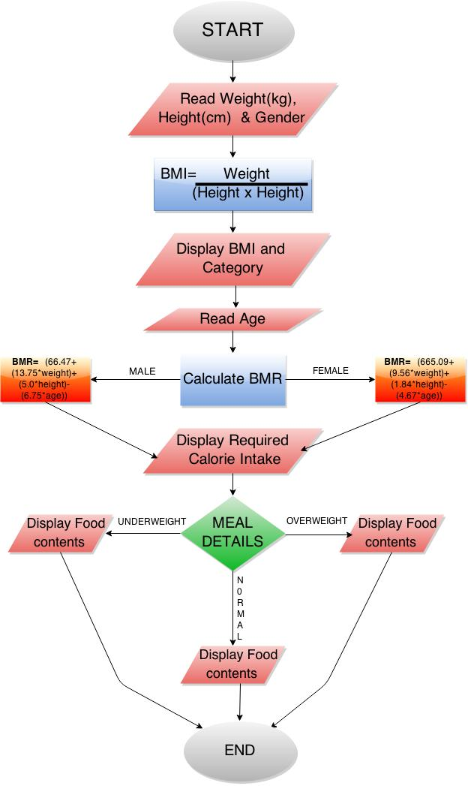

**3.2) SCREEN SHOTS OF THE APPLICATION**

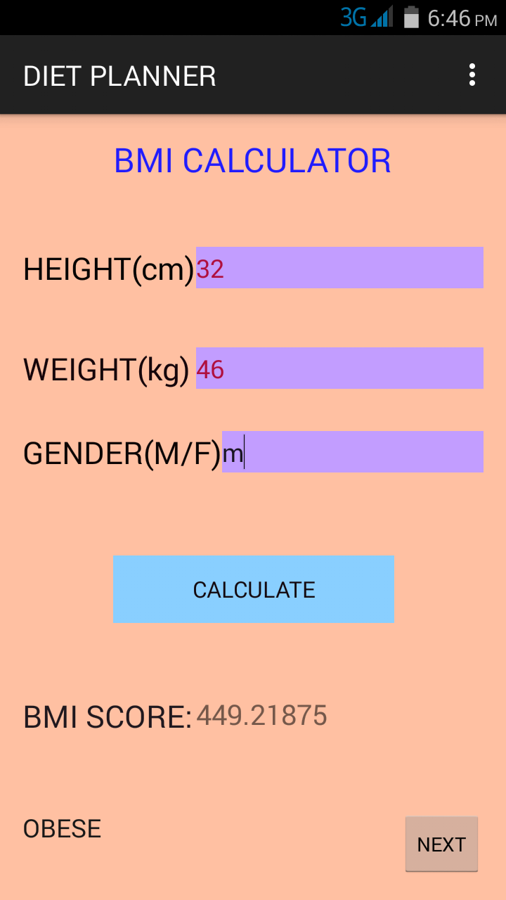

Figure 3.2.1

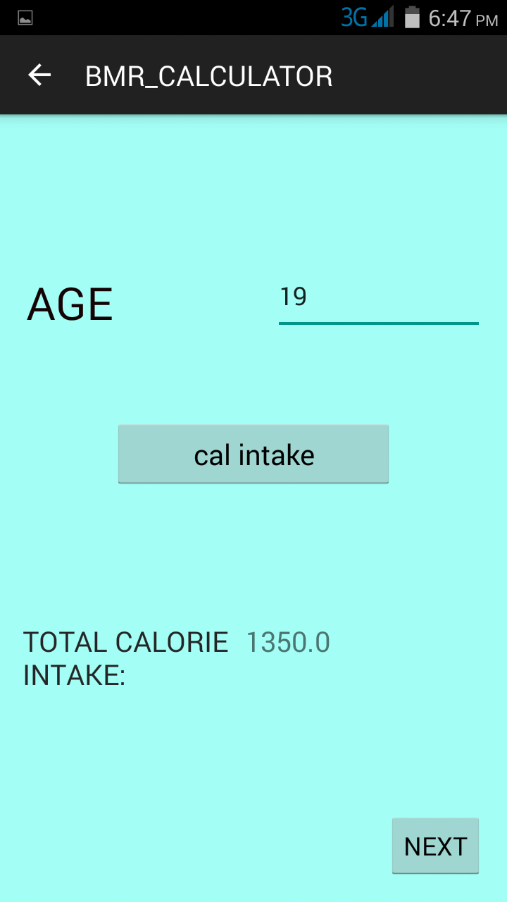

Figure 3.2.2

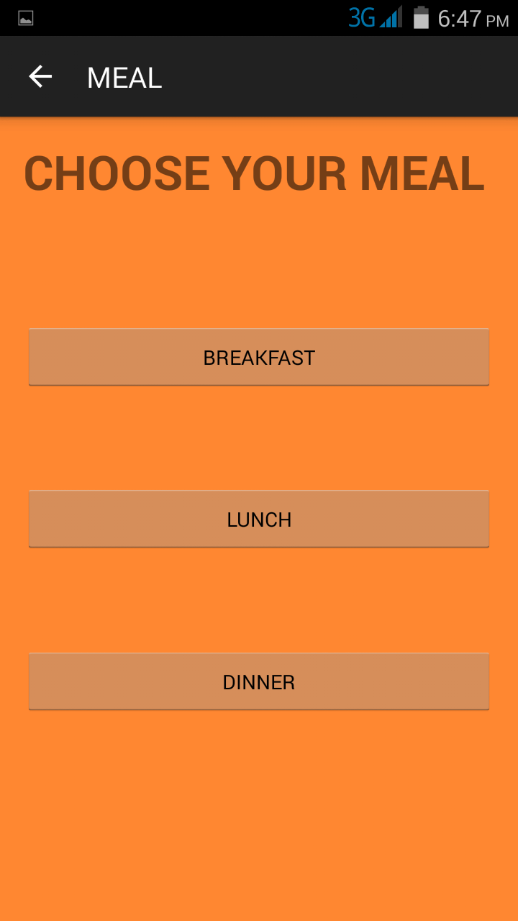

Figure 3.2.3

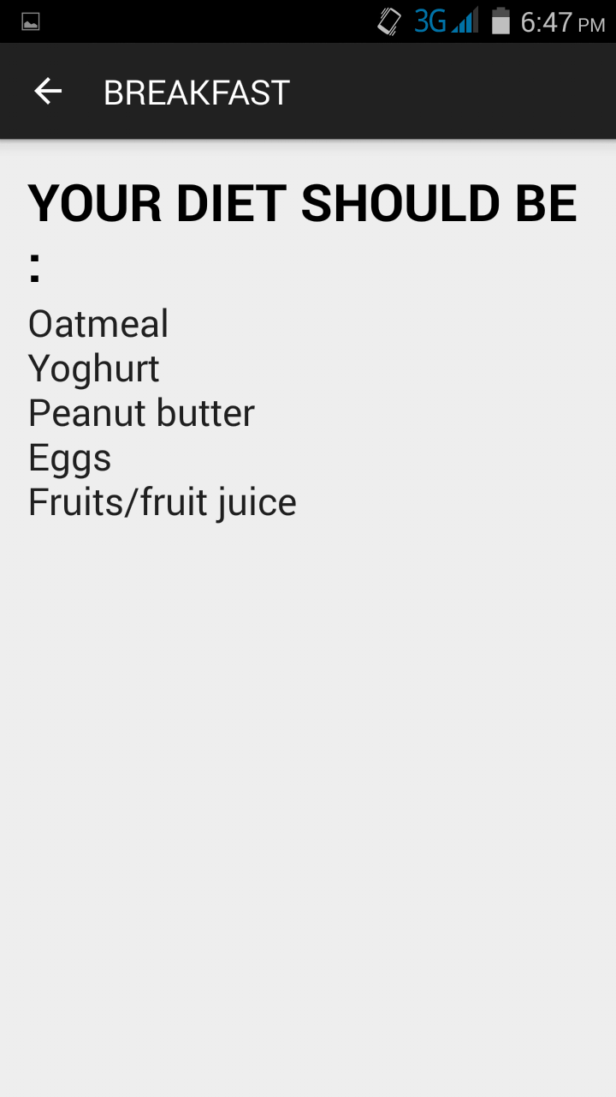

Figure 3.2.4

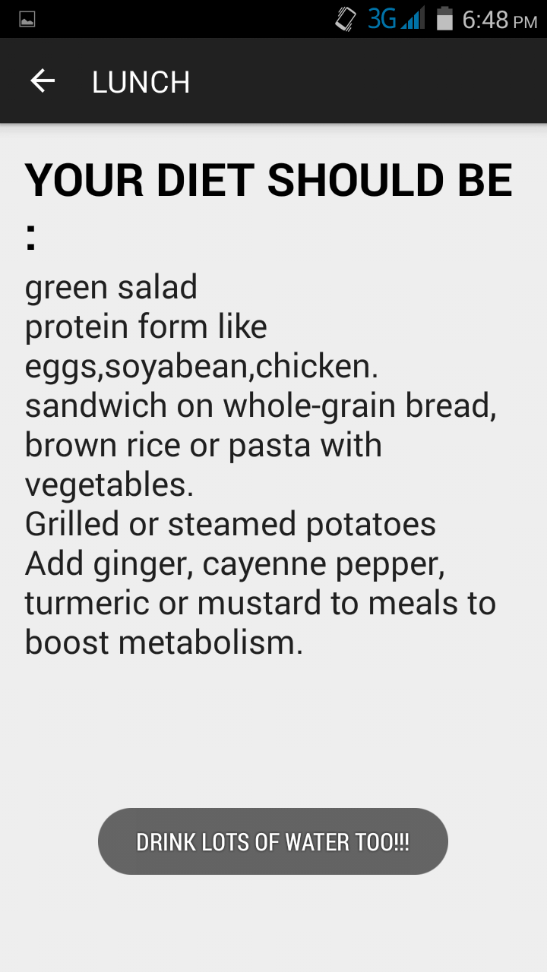

Figure 3.2.5

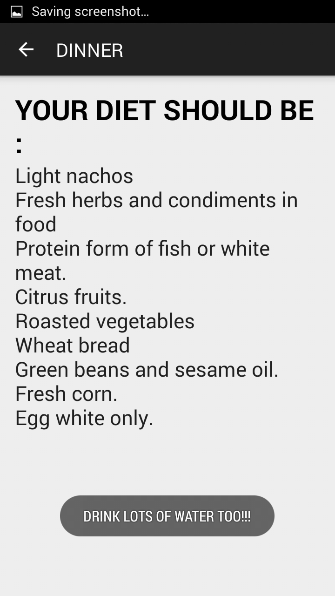

Figure 3.2.6

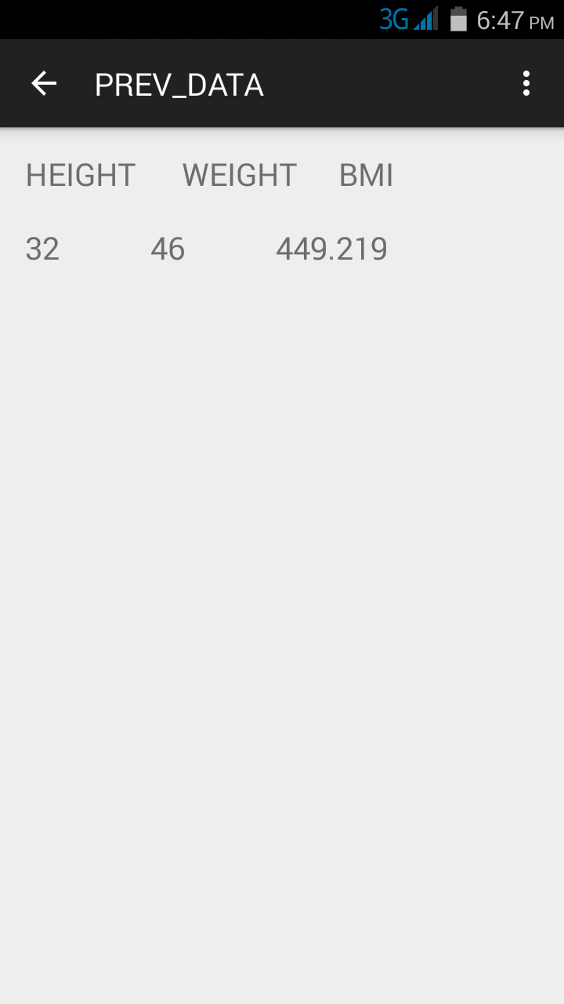

Figure 3.2.7

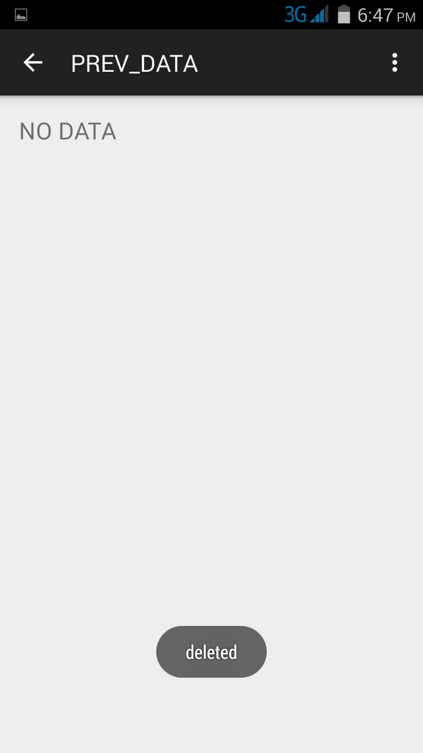

Figure 3.2.8

**3.3) LIMITATION OF THE APPLICATION**

1] Graphically lagging.

2] User interface not supported below 5” screen (use of dp instead of sp).

3] The application doesn’t make full use of the hardware of the phone like for ex. - the various sensors provided in today’s smartphone like the accelerometer, gyroscope meter are not utilized. Instead its just a simple application to let common man just know.

4] if the app is tried to be used with null values, it may malfunction.

5] the diet prepared is on the basis of standard food to injest rather than a wide varieties of options given in it.

**4) CONCLUSION AND FUTURE SCOPE**

Hence working on the above project proved to be very beneficial for us as we got to learn many new Android related technologies and also we learn how to use them in making applications which people can use in their daily life.

With the help of these technologies we have created the application called as diet planner which people can use to monitor their health.

And also in the long run this application can be useful for people to keep a track of their health related statistics.

Future scope

* Intended graph to be displayed to know the progress of the user by utilizing data from the database.
* Water intake calculator.
* Customizable diet plans with more food options.
* Macros Nutrients Calculator - How many grams of Carbohydrate, Protein, and Fat should you be eating at each  
  meal?

**5.) REFERENCES:**

1] <http://dailyburn.com/life/health/how-to-calculate-bmr/>

2] <http://en.wikipedia.org/wiki/Harris%E2%80%93Benedict_equation>

3] <http://www.whathealth.com/bmi/formula.html>

4] <http://www.nhs.uk/livewell/goodfood/pages/underweightadults.aspx>

5] <http://www.helpguide.org/articles/healthy-eating/healthy-eating.htm>

6] <http://www.ehow.com/way_5585191_healthy-diet-overweight-people.html>

7] Android developer 4.0 oxford publication.